**Name: E. Sai Manoj Mis. No.: 112015044**

**Input:**

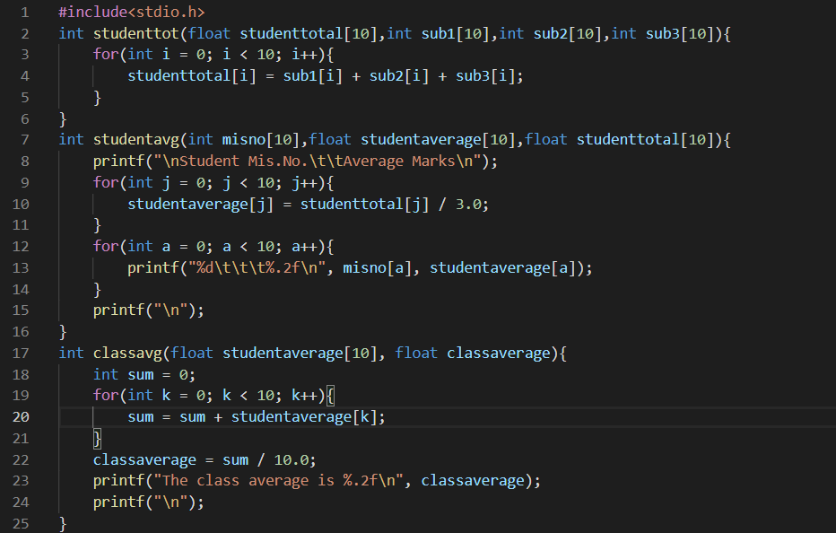

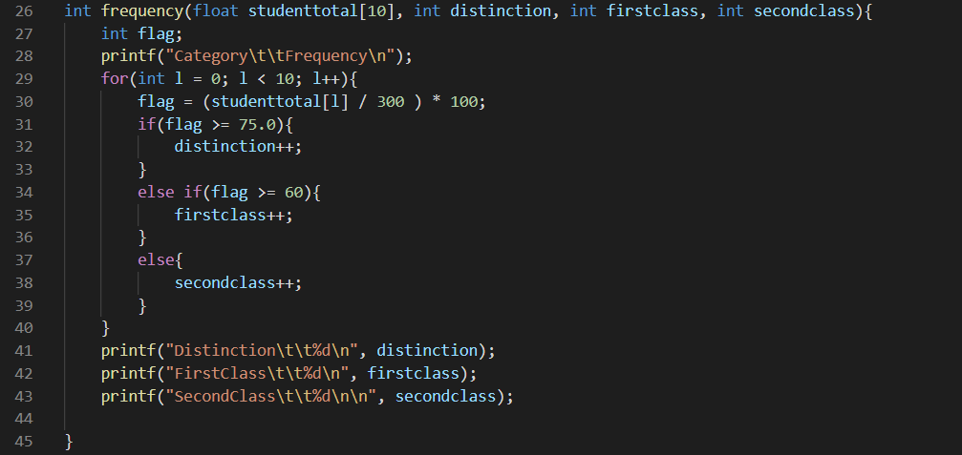

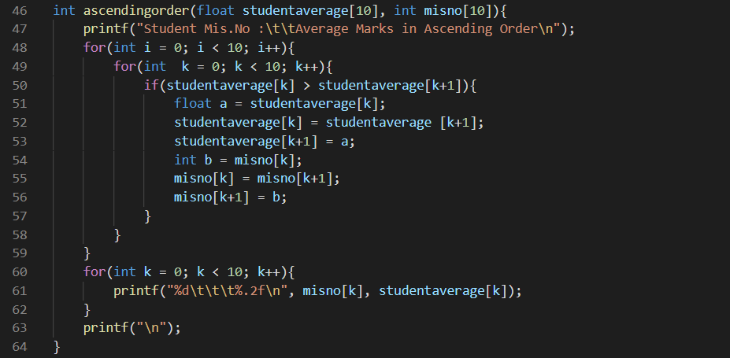

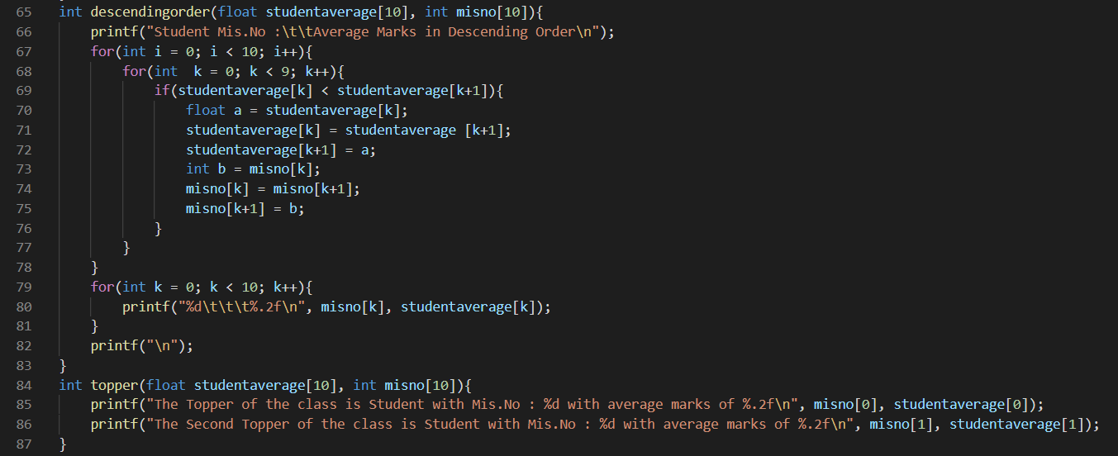

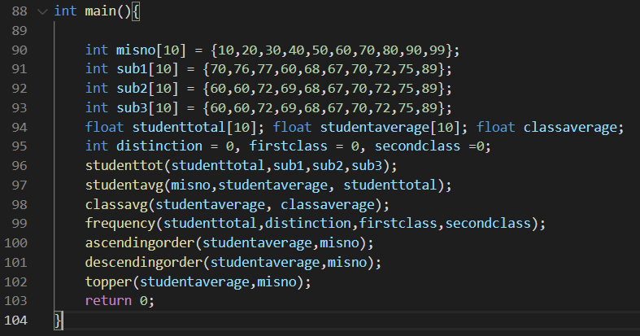

**Output:**

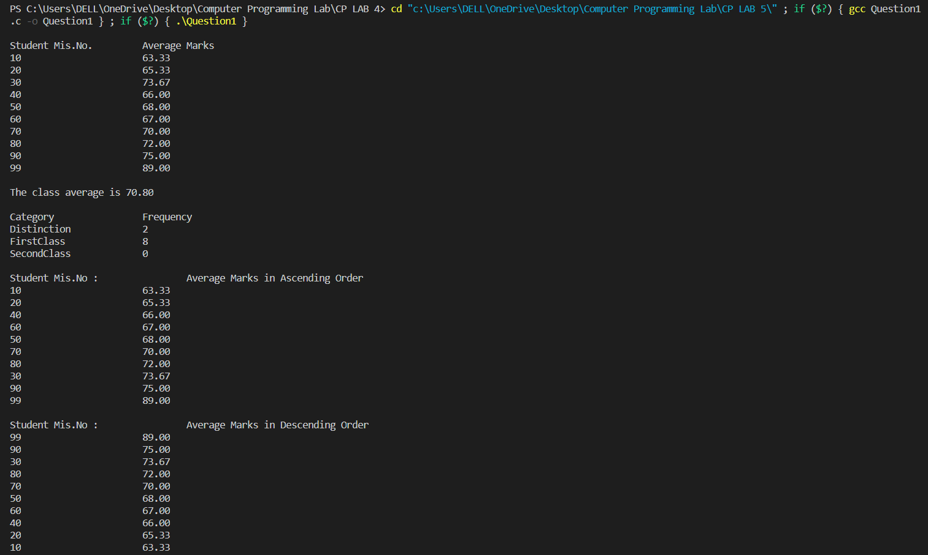

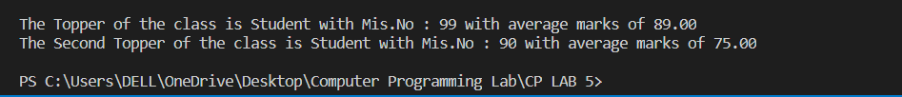

**Textual Input:**

**#include<stdio.h>**

**int studenttot(float studenttotal[10],int sub1[10],int sub2[10],int sub3[10]){**

**for(int i = 0; i < 10; i++){**

**studenttotal[i] = sub1[i] + sub2[i] + sub3[i];**

**}**

**}**

**int studentavg(int misno[10],float studentaverage[10],float studenttotal[10]){**

**printf("\nStudent Mis.No.\t\tAverage Marks\n");**

**for(int j = 0; j < 10; j++){**

**studentaverage[j] = studenttotal[j] / 3.0;**

**}**

**for(int a = 0; a < 10; a++){**

**printf("%d\t\t\t%.2f\n", misno[a], studentaverage[a]);**

**}**

**printf("\n");**

**}**

**int classavg(float studentaverage[10], float classaverage){**

**int sum = 0;**

**for(int k = 0; k < 10; k++){**

**sum = sum + studentaverage[k];**

**}**

**classaverage = sum / 10.0;**

**printf("The class average is %.2f\n", classaverage);**

**printf("\n");**

**}**

**int frequency(float studenttotal[10], int distinction, int firstclass, int secondclass){**

**int flag;**

**printf("Category\t\tFrequency\n");**

**for(int l = 0; l < 10; l++){**

**flag = (studenttotal[l] / 300 ) * 100;**

**if(flag >= 75.0){**

**distinction++;**

**}**

**else if(flag >= 60){**

**firstclass++;**

**}**

**else{**

**secondclass++;**

**}**

**}**

**printf("Distinction\t\t%d\n", distinction);**

**printf("FirstClass\t\t%d\n", firstclass);**

**printf("SecondClass\t\t%d\n\n", secondclass);**

**}**

**int ascendingorder(float studentaverage[10], int misno[10]){**

**printf("Student Mis.No :\t\tAverage Marks in Ascending Order\n");**

**for(int i = 0; i < 10; i++){**

**for(int k = 0; k < 10; k++){**

**if(studentaverage[k] > studentaverage[k+1]){**

**float a = studentaverage[k];**

**studentaverage[k] = studentaverage [k+1];**

**studentaverage[k+1] = a;**

**int b = misno[k];**

**misno[k] = misno[k+1];**

**misno[k+1] = b;**

**}**

**}**

**}**

**for(int k = 0; k < 10; k++){**

**printf("%d\t\t\t%.2f\n", misno[k], studentaverage[k]);**

**}**

**printf("\n");**

**}**

**int descendingorder(float studentaverage[10], int misno[10]){**

**printf("Student Mis.No :\t\tAverage Marks in Descending Order\n");**

**for(int i = 0; i < 10; i++){**

**for(int k = 0; k < 9; k++){**

**if(studentaverage[k] < studentaverage[k+1]){**

**float a = studentaverage[k];**

**studentaverage[k] = studentaverage [k+1];**

**studentaverage[k+1] = a;**

**int b = misno[k];**

**misno[k] = misno[k+1];**

**misno[k+1] = b;**

**}**

**}**

**}**

**for(int k = 0; k < 10; k++){**

**printf("%d\t\t\t%.2f\n", misno[k], studentaverage[k]);**

**}**

**printf("\n");**

**}**

**int topper(float studentaverage[10], int misno[10]){**

**printf("The Topper of the class is Student with Mis.No : %d with average marks of %.2f\n", misno[0], studentaverage[0]);**

**printf("The Second Topper of the class is Student with Mis.No : %d with average marks of %.2f\n\n", misno[1], studentaverage[1]);**

**}**

**int main(){**

**int misno[10] = {10,20,30,40,50,60,70,80,90,99};**

**int sub1[10] = {70,76,77,60,68,67,70,72,75,89};**

**int sub2[10] = {60,60,72,69,68,67,70,72,75,89};**

**int sub3[10] = {60,60,72,69,68,67,70,72,75,89};**

**float studenttotal[10]; float studentaverage[10]; float classaverage;**

**int distinction = 0, firstclass = 0, secondclass =0;**

**studenttot(studenttotal,sub1,sub2,sub3);**

**studentavg(misno,studentaverage, studenttotal);**

**classavg(studentaverage, classaverage);**

**frequency(studenttotal,distinction,firstclass,secondclass);**

**ascendingorder(studentaverage,misno);**

**descendingorder(studentaverage,misno);**

**topper(studentaverage,misno);**

**return 0;**

**}**